**Sense of Taste**

Here is a script to teach about the Sense of Taste

Tell me something you like to eat. Why do you like to eat that? (Because I like it.......!) What do you like about it**? I LIKE THE WAY IT TASTES!!**  (is the answer we're looking for here!).

What part of your body TASTES your food? YOUR TONGUE! Different parts of your tongue taste different tastes!

If something is SWEET (like sugar, candy, cake frosting) the front part your tongue tastes that!

If something is SALTY (like potato chips, pretzels, bacon) the very tip of your tongue and around the sides tastes that!

If something is SOUR (like a lemon, lime, sour patch candy) both sides of your tongue a bit farther back tastes that!

Bitter things (like grapefruit, marmalade, coffee) are tasted by the very back middle part of the tongue.

If you want to -- Google **"Parts of the tongue and taste"** and you can see a picture / diagram.

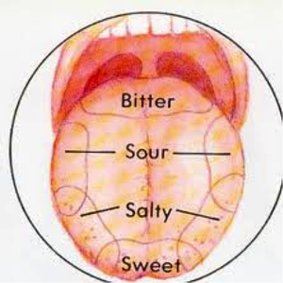

Not all people like the same tastes! Some people like things that are SWEET; some people prefer things that are SALTY, and some like SOUR. It's all a matter of TASTE!!

If you'd like --- have a Food tasting to tell the difference between sweet, sour and salty. I don't think anyone needs to know about bitter taste at this point!

Worksheet: **Fabulous Food**